Instructions to Authors
LE2017
A. B. Bell¹, C. D. Thomas²
1 University/Company, Address, Country
2 University/Company, Address, Country
presenters@mail.address
Abstract: This provides instructions to authors for completing final manuscripts which will be included in the Proceedings. You must prepare a PDF file of the manuscript of your paper and submit it from the web site: http://www.le-symposia.org/entry/login.php Please keep in mind that the manuscript sent will be included in the Proceedings as it is received. The authors are therefore kindly requested to observe the following instructions for the preparation of their manuscripts.
Keywords: Selected three to five keywords relevant to the subject.

1. Typing
The size of the manuscript must be A4 and it should be typed in two columns with single spacing. The Times Roman typeface of 10 points or greater is preferred.
To ensure uniformity of appearance for the Proceedings, your paper should conform to the following specifications. If your paper deviates significantly from these specifications, it may not be included in the Proceedings.
- The distance from the top edge of the paper to the top of the first line of type should be 2.7 cm.
- The distance from the left edge of the paper to the left margin of the type should be 1.5 cm.
- The distance from the right edge of the paper to the right margin of the type should be 1.5 cm.
- The distance from the bottom of the last line of type on the page to the bottom edge of the paper should be at least 2.0 cm.
- The text should be centered left-to-right on the page.
- The width of each column should be 8.5 cm.
- The distance between the two columns of text should be 1.0 cm.
The number of pages allowed for the final manuscript is 2~6 pages.
The size of PDF file to be sent by email should not exceed 25 megabytes (25 MB), regardless of the number of pages.

2. First Page
The title should be centered across the top of the first page and should be in a distinctive font. The authors’ names and addresses should be centered below the title.
The abstract and the main body follow as indicated on this document. Your abstract should be about 100 words, and it should give a brief account of the most relevant aspects of the paper.
The main body should start with an Introduction that includes a statement of the purpose and the contribution of the paper.
3. Headings
3.1 Main headings
Main headings are to be column centered in a bold font or in capitals. Leave a space of two lines above and one line below these headings.
3.2 Subheadings
Subheadings should be in a bold font or underlined lower case with initial capitals. They should be placed flush on the left-hand margin of the column.
Sub-subheadings: Sub-subheadings should be in a bold font or underlined type. They should run in at the beginning of the paragraph.
4. Illustrations
Illustrations should be incorporated into the text area as close as possible to the first reference to them. Photographs may also be pasted into their respective places.
Each illustration should have a space of approximately two lines above and one line below. The figure number and caption should be typed below the illustration. The word ‘Figure’ should be shortened to ‘Fig.’ at the beginning of the figure caption. It should also be shortened to Fig. in the text except where it begins a sentence.

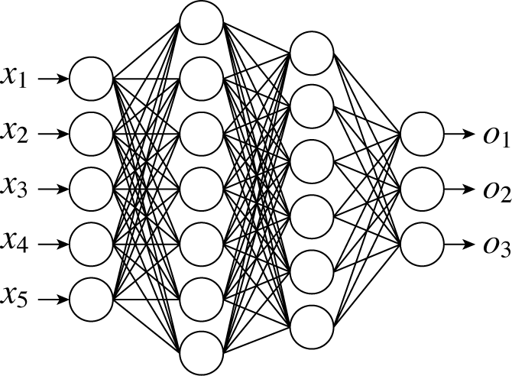
Fig. 1: A neural network structure

5. Tables
Tables should be typed within the typed area. Leave one line space after the text and type the table heading, including the table number, above the table. Leave one line space between the heading and the table.

Table 1: Colors and corresponding RGB values

Color | Red | Green | Blue
Black  Blue  Magenta  Yello  White | 0  0  255  255  255 | 0  0  0  255  255 | 0  255  255  0  255

6. Equations
Equations should be typed within the text and should be numbered consecutively throughout the typescript. The equation number should be typed in parenthesis, flush with the right-hand margin of the column.

(1)
7. References
References should be numbered and appear at the end of the paper. All references listed must be cited in the text at an appropriate point in superscript form as shown at the end of this sentence¹⁾.
The form of listed reference is as follows:
- Style for papers: Author(s), title, name of journal, volume and number, inclusive page numbers, year.
- Style for books: Author(s), title, chapter or page numbers, name of publisher, year.
8. Additional Information
If you have no access to the Conference web site or you have any trouble with sending the PDF file electronically, you may send the PDF manuscript to the SICE office by electronical mail. Do not type page numbers: your manuscript will be repaginated for the publication.
References
[1] A. U. Thor, How to prepare the manuscript for SICE2005, The Journal of SICE, Vol. 0, No. 0, pp. 00-00, 2005.

